Spring Framework – Introduction

EXAMPLE WHY WE NEED FRAMEWORK?

Normal Website vs Amazon/Flipkart
Normal Website or Government Website:
- When many users visit the website at the same time, the server may become slow or unavailable.
- This can happen because of limited server capacity, poor optimization, or lack of proper load balancing.
- Example: A government exam result website may become slow when lakhs of students try to check their results at the same time.
Amazon or Flipkart:
- These websites are designed to handle a large number of users.
- They use scalable cloud infrastructure, load balancing, caching, CDNs, and other technologies.
- They can add more computing resources when traffic increases.
- However, even these websites can sometimes experience downtime.

Where Does a Framework Help?
A framework like Spring Boot, Django, Laravel, or ASP.NET helps developers build and maintain websites efficiently.
But a framework alone cannot prevent server downtime. Proper server infrastructure, database optimization, caching, load balancing, and scalability are also important.
Real-time example: Imagine a shopping mall. If only one billing counter is available, a large crowd creates a queue. If the mall opens multiple billing counters and manages the queues properly, more customers can be served efficiently.
Similarly, load balancing distributes website requests across multiple servers.

What is Spring?
Spring is a Java framework used to develop web applications, enterprise applications, and backend systems.
A framework provides ready-made tools, features, and a structure that helps developers build applications more easily.
Spring helps developers manage Java objects, connect different classes, work with databases, and develop applications with less repetitive code.
In simple words, Spring makes Java application development easier, more organized, and easier to maintain.

Real-Time Example
Imagine you want to develop a Student Management System using Java.
The system needs to register students, display student details, update student information, and store records in a database.
Spring provides features that help developers organize these tasks into separate components and connect them properly.

Why Do We Need Spring?
When we develop a large application using only Core Java, we need to manage many things ourselves, such as creating objects, connecting classes, handling database operations, and organizing application logic.
As the application grows, maintaining these things can become difficult.
Spring helps solve these problems.
- Object management: Spring can create and manage objects for the application.
- Connecting classes: Spring can provide the objects that other classes need.
- Database operations: Spring supports integration with database technologies.
- Web application development: Spring provides features for handling web requests and responses.
- Application structure: Spring helps developers separate different responsibilities into different components.
- Testing: Spring supports testing application components independently.
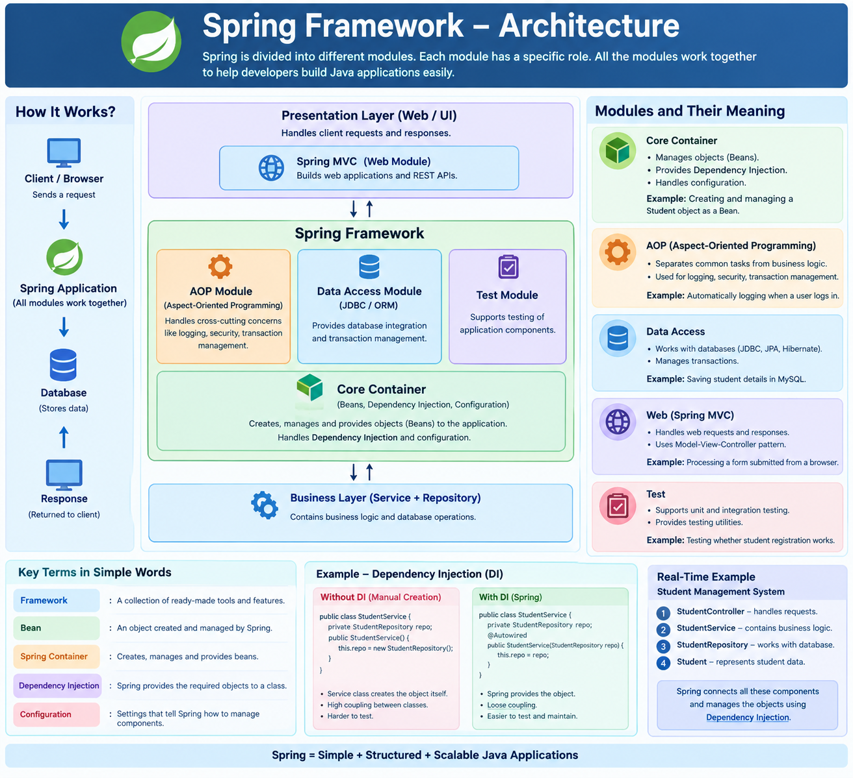
A framework is a collection of ready-made tools and features that helps developers build applications.
Example: Spring provides features to manage objects and handle web requests, instead of making developers build everything from scratch.
Module
A module is a separate part of the framework that performs a particular job.
Example: The Core Container manages objects, while the Data Access module supports database operations.
Core Container
The Core Container is the basic part of Spring that creates and manages objects.
Example: Spring creates a StudentService object and manages it when the application needs it.
Bean
A Bean is an object created and managed by the Spring Container.
Example: If Spring creates and manages a StudentService object, that object is called a Spring Bean.
Dependency
A dependency is an object or service that a class needs to perform its work.
Example: StudentService needs StudentRepository to save student details. Therefore, StudentRepository is a dependency of StudentService.
Dependency Injection (DI)
Dependency Injection means providing a class with the objects it needs instead of making the class create those objects itself.
Without Spring:
StudentRepository repo = new StudentRepository();
Here, the service creates the repository object itself.
With Spring:
@Service
public class StudentService {

private final StudentRepository repo;

public StudentService(StudentRepository repo) {
this.repo = repo;
}
}
In this example, Spring can provide the StudentRepository Bean through the constructor when creating StudentService, provided that the repository is configured as a Spring Bean.
Why is this useful? The service does not need to create the repository itself. This makes the classes easier to test and maintain.
Configuration
Configuration means the settings or instructions that tell Spring how to set up and manage application components.
Example: Using @Configuration and @Bean to tell Spring how to create a particular object.

Spring Bean Life Cycle
The Spring Bean Life Cycle explains how Spring creates an object, prepares it for use, manages it, and destroys it when required.
Example: In a Student Management System, Spring creates a StudentService object and manages it while the application is running.

Stages of Spring Bean Life Cycle

Bean Definition
Spring first identifies which classes and objects it needs to manage using annotations or configuration.
Example: @Service tells Spring that StudentService is a service component that can be managed as a Bean.
@Service
public class StudentService {
}

Instantiation
Instantiation means creating an object of a class.
Spring creates the Bean object using a suitable constructor.
Example: Spring creates an object of StudentService.

Dependency Injection
Dependency Injection means providing a Bean with the other objects it needs to work.
Example: StudentService needs StudentRepository to save student details. Spring provides the repository object to the service.

Initialization
After creating the Bean and injecting its dependencies, Spring performs initialization callbacks.
Initialization means preparing the object before it is used.
Example: We can use @PostConstruct to run a method that loads required initial data.
@PostConstruct
public void init() {
System.out.println("StudentService is ready");
}
Spring calls this method after dependency injection.

Bean Ready for Use
After initialization, the Bean is ready for the application to use.
Example: A controller calls StudentService to register a student.

Destruction
When the Spring container shuts down, it calls the appropriate destruction callbacks for managed Beans.
Destruction is used to clean up resources when required.
Example: A Bean that manages a resource can close it during shutdown using @PreDestroy.
@PreDestroy
public void cleanup() {
System.out.println("StudentService is shutting down");
}

Simple Flow to Remember
Bean Definition
Instantiation — Create object
Dependency Injection — Provide required objects
Initialization — Prepare the object
Bean Ready for Use
Destruction — Clean up when the container shuts down
Important terms to remember:
- @Service — identifies a service component.
- @Autowired — requests dependency injection.
- @PostConstruct — runs a method during initialization.
- @PreDestroy — runs a method before destruction.

Example :
1) SpringHelloWorld
2) Spring Lifecycle

